Name: Anh Quoc Nguyen
Matriculation number: 1397466

EDD – 1. Taskset: { T1 (2, 10); T2 (1, 4); T3 (4, 12) }
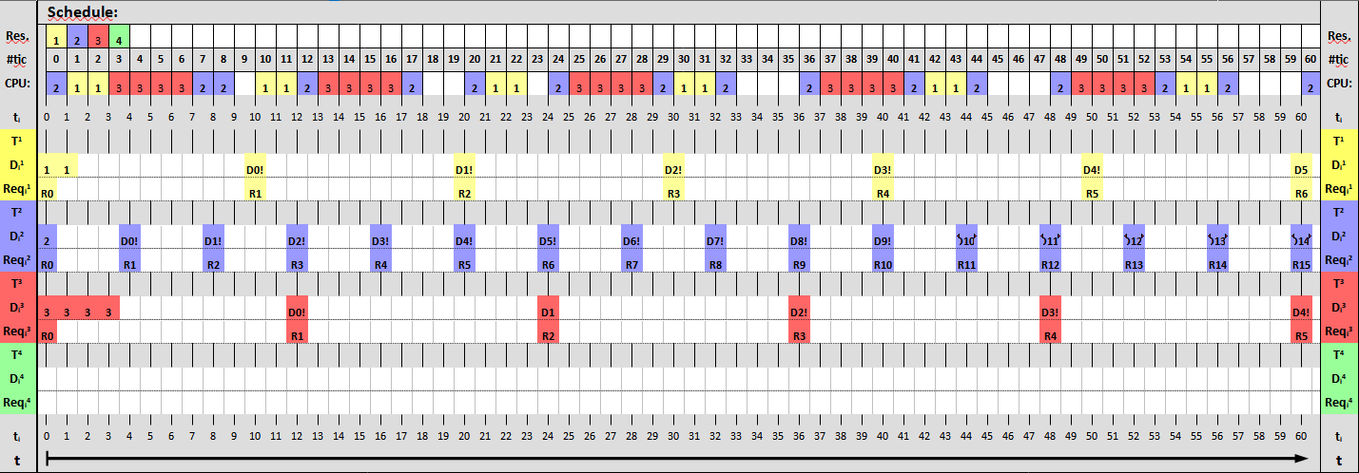

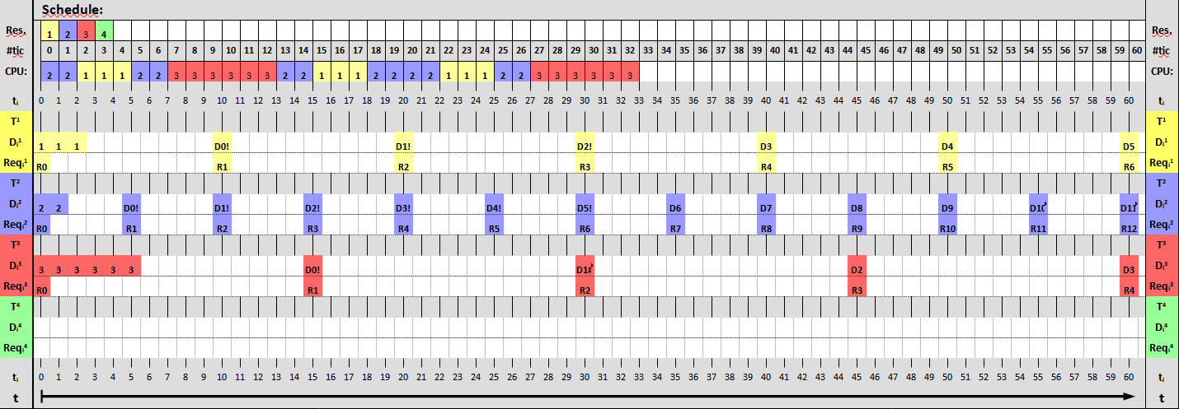
EDD – 2. Taskset: { T1 (3, 10); T2 (2, 5); T3 (6, 15)

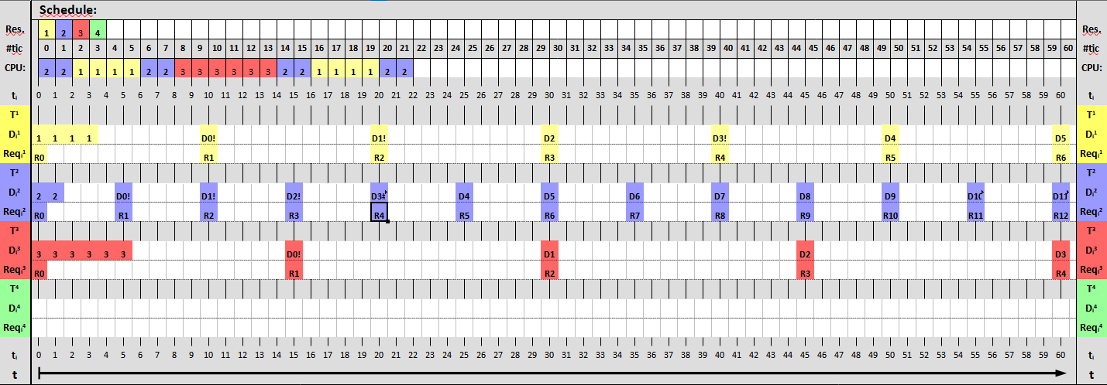
EDD – 3. Taskset: { T1 (4, 10); T2 (2, 5); T3 (6, 15) }
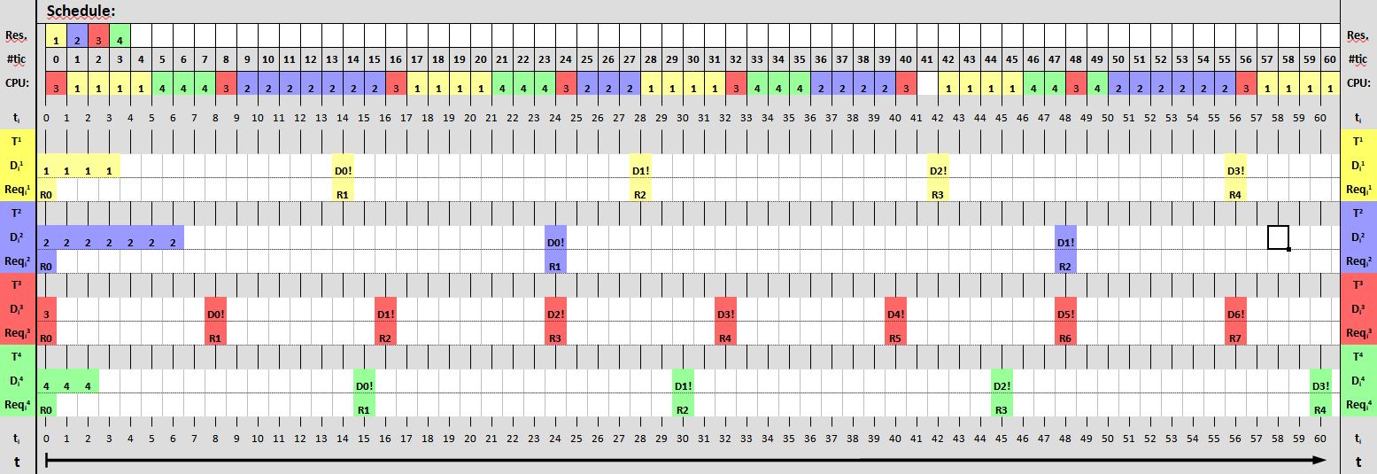
EDF – 1. Taskset: { T1 (4, 14); T2 (7, 24); T3 (1, 8); T4(3, 15)}
EDF – 2. Taskset: { T1 (3, 12); T2 (7, 20); T3 (4, 10)}
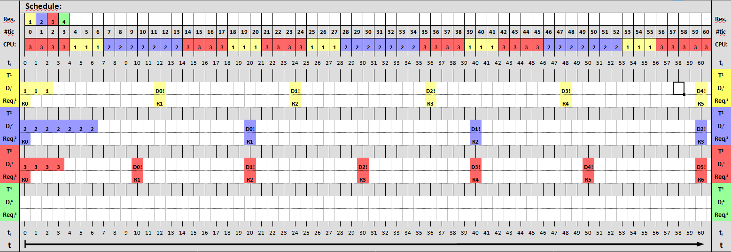
EDF – 3. Taskset: { T1 (6, 20); T2 (3, 12); T3 (4, 10)}
